
Contact No’s: 9906041342,9906515202
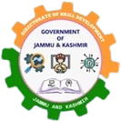
OFFICE OF THE PRINCIPAL,
KASHMIR GOVT. POLYTECHNIC COLLEGE GOGJI BAGH
SRINAGAR.
Website: https://www.kgpsrinagar.edu.in.
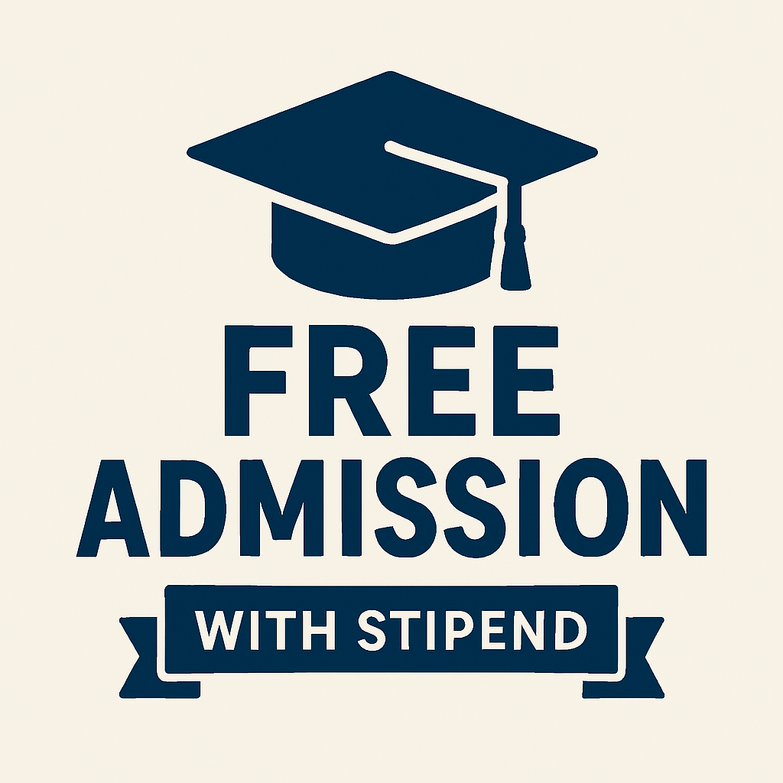
Email: kgp-srinagar@jk.gov.in.
Scheme: “Chief Minister’s scheme for introduction of Heritage courses”
ADMISSION NOTICE 01 OF 2025
FOR
WOOD CARVING ARTISAN COURSE

Online Applications are invited from desirous candidates for seeking admission for the session 2025–26 in the WOOD CARVING ARTISAN-Heritage course being conducted under the “Chief Minister’s scheme for introduction of Heritage courses” at Kashmir Govt. Polytechnic College Srinagar. Interested candidates can submit their details on the google form link given below or by scanning QR code.
Link is: https://forms.gle/TfVkYBgCouKiE45k7
QR CODE
Details of the course:

S.NO | TRADE/COURSE TITLE | DURATION | INTAKE | NCVT/SCVT | ELIGIBILTY
1 | WOOD CARVING ARTISAN | ONE YEAR | 20 | SCVT | 10th Pass
Important Information:
- Last Date for applying online is 07-11-2025.
- Upon submission of details via the designated Google Form, a selection list will be prepared based on the marks secured by candidates in the matriculation examination. Shortlisted candidates will be notified via phone and email. All selected candidates are required to complete the admission formalities by 09-11-2025. Failure to do so within the stipulated deadline will result in forfeiture of their claim to admission.
- Candidates will be selected based on the marks secured in the Matriculation examination.
- Examination shall be conducted through Board of Technical Education, J&K under SCVT Scheme.
- Successful candidates shall be awarded with STC Certificates.
- Stipend of ` 1000 per trainee/month shall be provided for the prescribed duration of the training.
- Candidates availing stipend from any other UT/State/Govt. of India scheme shall not be entitled for stipend being provided under this scheme. The trainees shall be paid stipend through DBT mode.
- For Any query, Call /WhatsApp on 9906041342,9906515202.

Principal
No: KGP/Estt/2025/1516-1520
Dated:03-11-2025

Kashmir Govt. Polytechnic College
Srinagar
Copy to the:
- Director, Skill Development Department, UT of J&K, Srinagar/Jammu for information.
- Deputy Director Trainings, Skill development department, for information.
- Joint Director, Information Department, Kashmir, Srinagar — with a request to kindly publish this notification in two leading local daily newspapers for at least three days.
- I/C Website for information and necessary action.

